RedEye

Smart Phone Based Web Development

Project Report

-Submitted by Raghuram Parthasarathy

Contents

Project Proposal: 3

Problem Statement: 3

Inefficiences in the existing system: 3

Proposed Solution: 3

Benefits of the new application: 3

Data Model: 4

Screen Appearance: 5

Register Screen with Validations 5

Login Screen with Validations: 6

Student Home and Account details Screen 7

Student Ride history and Feedback Screen 8

Account Validation 9

Date and Time Picker for ride request: 10

Slots filled and NUPD help Screen: 11

Trend Analysis of rides for each hour in terms of counts as well as percentage: 12

Shuttle Locator and Student booking histories for Driver: 13

Back4app Server integration: 14

Future Scope: 14

# 

# Project Proposal:

To develop an IOS application to enhance and efficiently utilize NEU’s Red Eye shuttle service .

# Problem Statement:

Students at Northeastern University are facing a hard time while waiting for the University shuttle every evening. They need to stand in a long queue for the shuttle which arrives every 30 minutes. The shuttle can accommodate only 9 students and the remaining student who stands in the long queue should wait for another 30 minutes. This long wait makes things worse during winter as well as rainy seasons. Students will stand in the same spot when it rains/snows in order to get a valuable seat. Some action has to be taken for such problems.

# Inefficiences in the existing system:

* Time delay and resources wastage due to bad route selection.
* Student traffic is not tracked/estimated.
* Fixed frequency on every day/season.
* Difficult for drivers who are new to Boston.
* Long wait makes things worse during winter as well as rainy seasons.

# Proposed Solution:

By having a mobile application, student will no longer have to wait in long queues. They can simply register for a shuttle service by logging in to the application as a student and register the time slot they are looking to travel. If a particular time slot is filled for 9 students, the next student who tries to book will not be able to register for the service. Instead they will be provided with the next available time slot to register. This will hinder the need of forming a never ending long queues and it will be very much student friendly.

# Benefits of the new application:

* By having a mobile application, student will no longer have to wait in long queues
* Efficient route map
* Digital record conversion of trip data with feedbacks to the drivers
* Operational efficiency of shuttle – control over the frequency based on traffic and resource
* Informed and connected travel – facility to track the shuttle
* All the student address and the history for each trip will be stored in the Northeastern University Police Department (NUPD) database for future references.
* Students will also have an option to submit a feedback in the mobile app if in case they are not happy with their trip.
* The address of the student for the respective time slot will be auto populated in the shuttle driver’s phone, so that the driver can confirm the student’s identity before starting the trip.
* Business Intelligence/Analytics will help to improve the service

# Data Model:

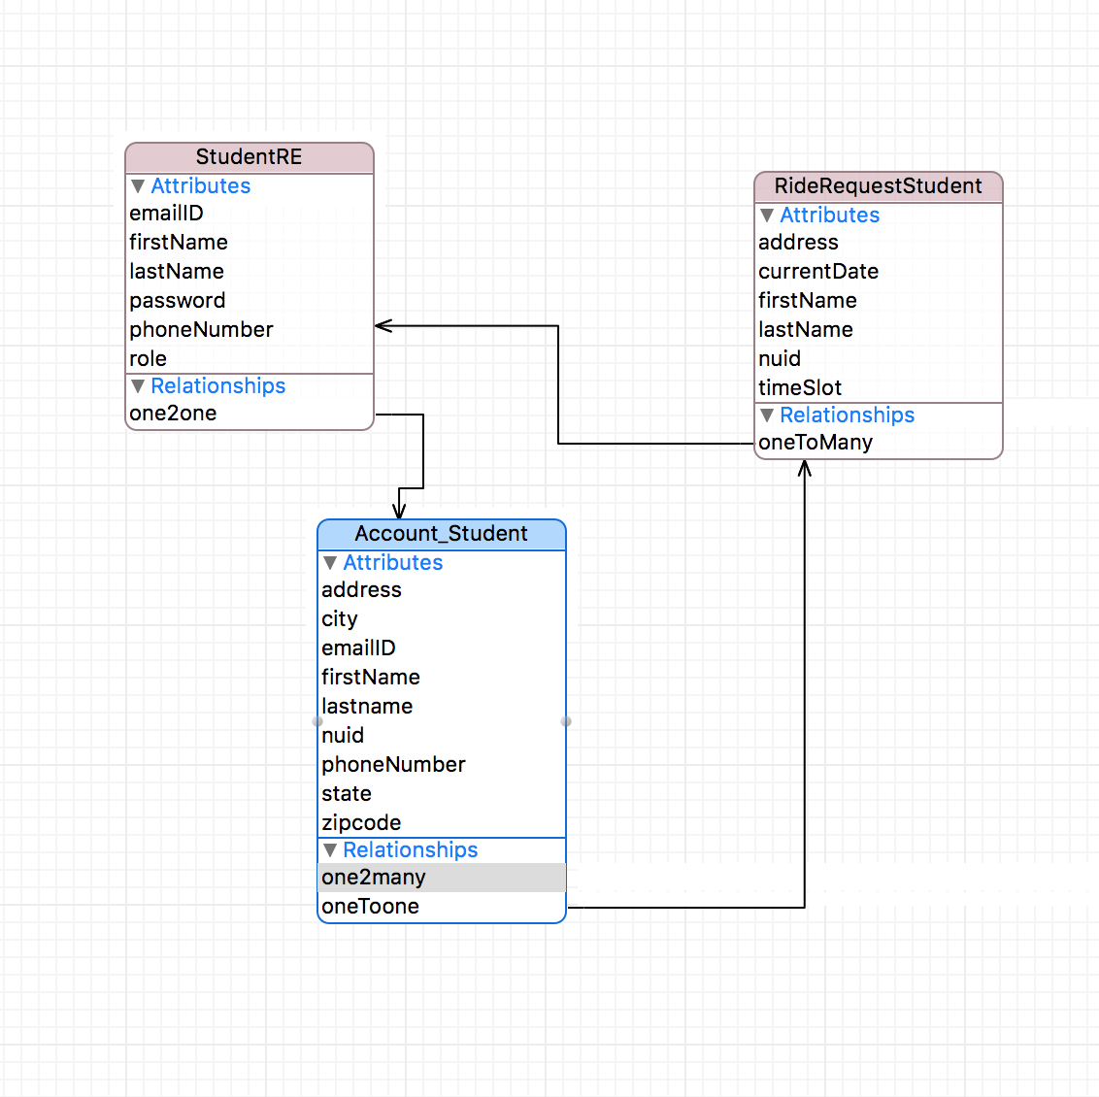

***Steps to run the program in XCode:***

***Step1:*** Unzip the Application

***Step2:*** Open X-Code and Select Open Another Project

***Step3:*** Double click on Raghuram_Parthasarathy_RedEye_Final_Project->> RedEye_Final_Project

***Step4:*** Run the application

# Screen Appearance:

## Register Screen with Validations

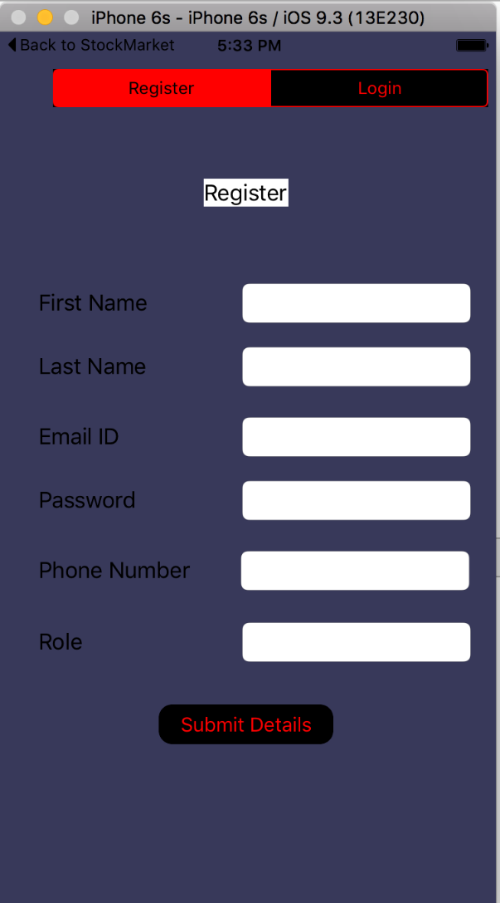

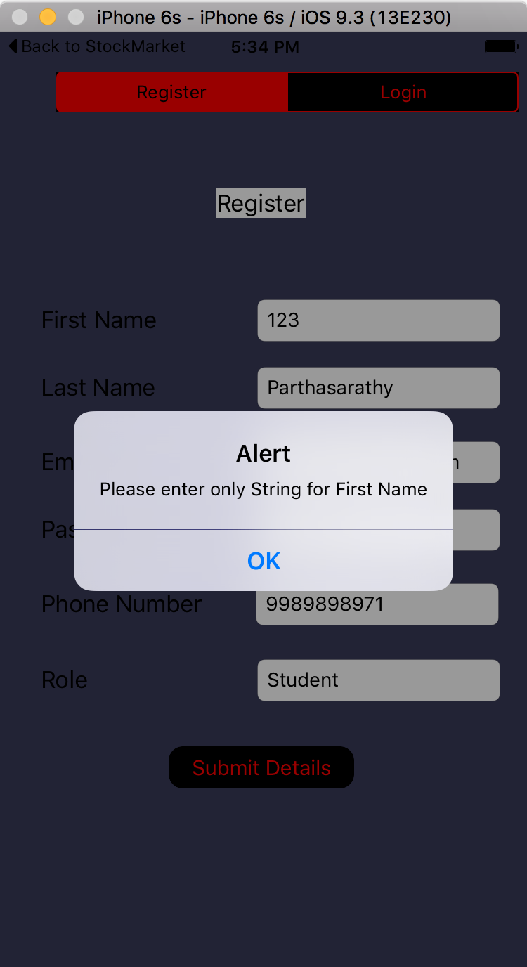

## Login Screen with Validations:

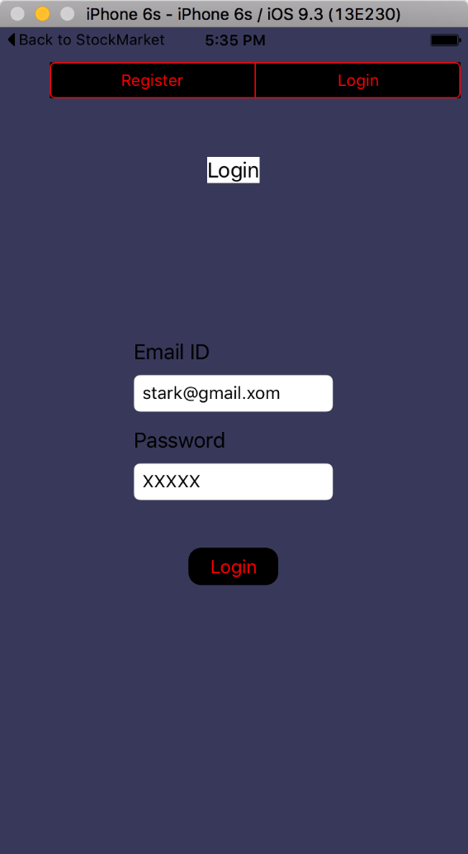

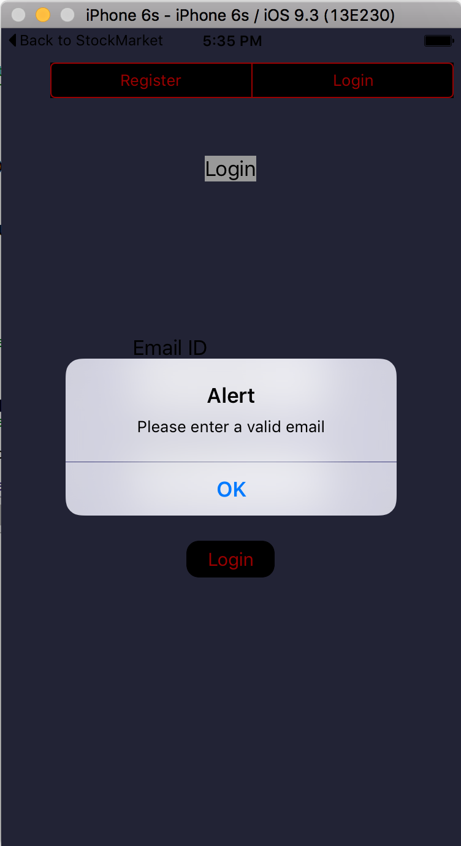

## Student Home and Account details Screen

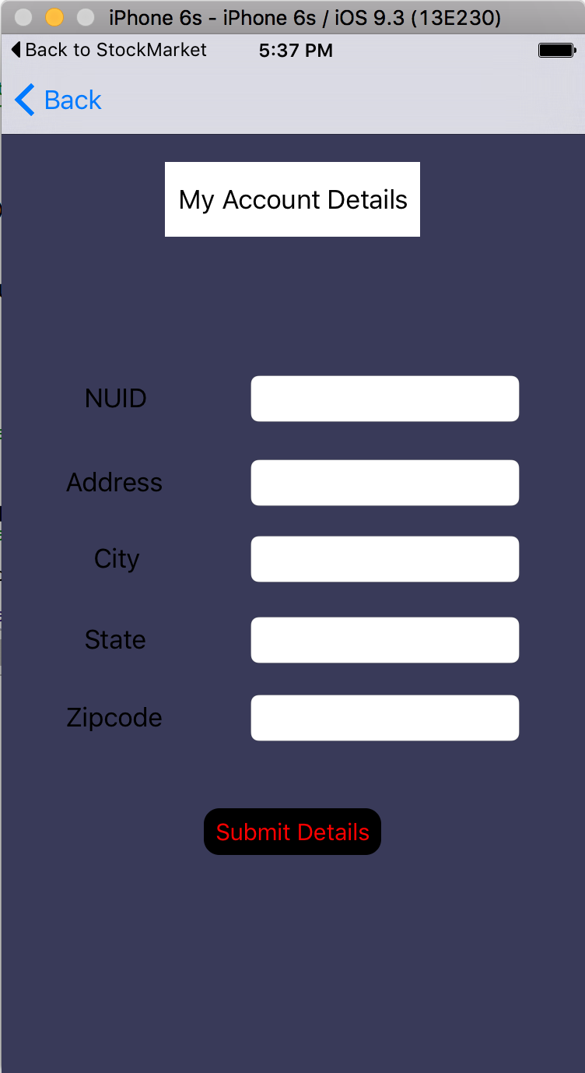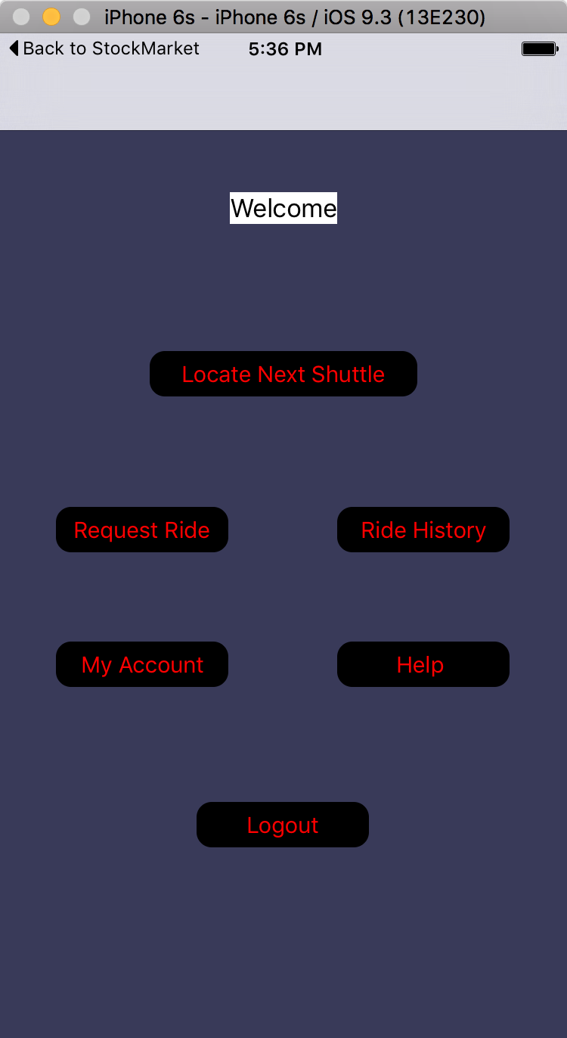

## Student Ride history and Feedback Screen

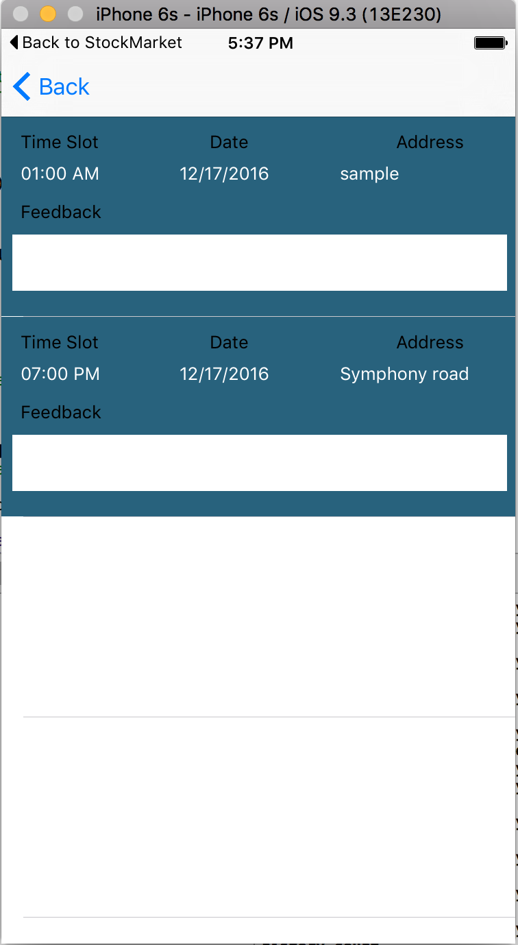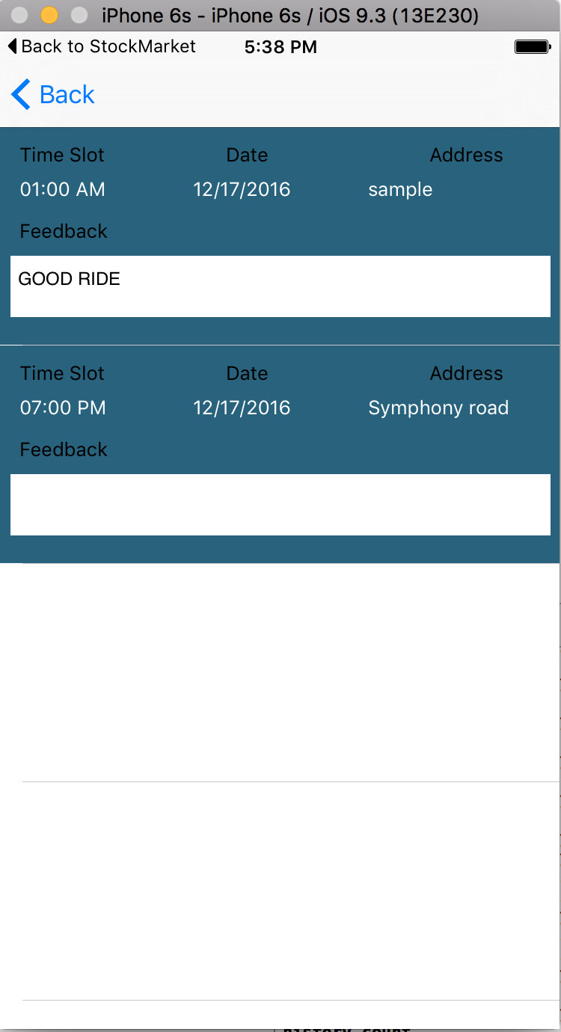

## Account Validation

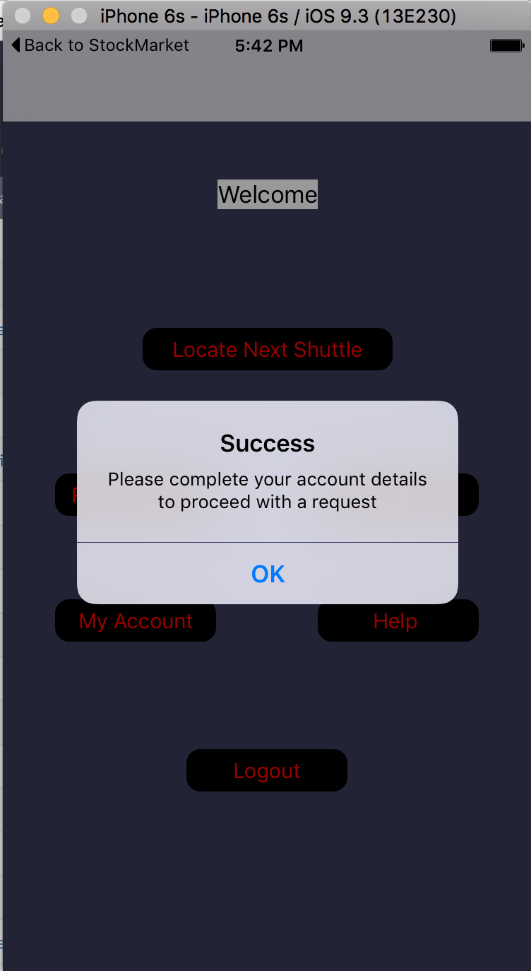

First time login students will be able to book for a ride only if they fill up the account details section.

## Date and Time Picker for ride request:

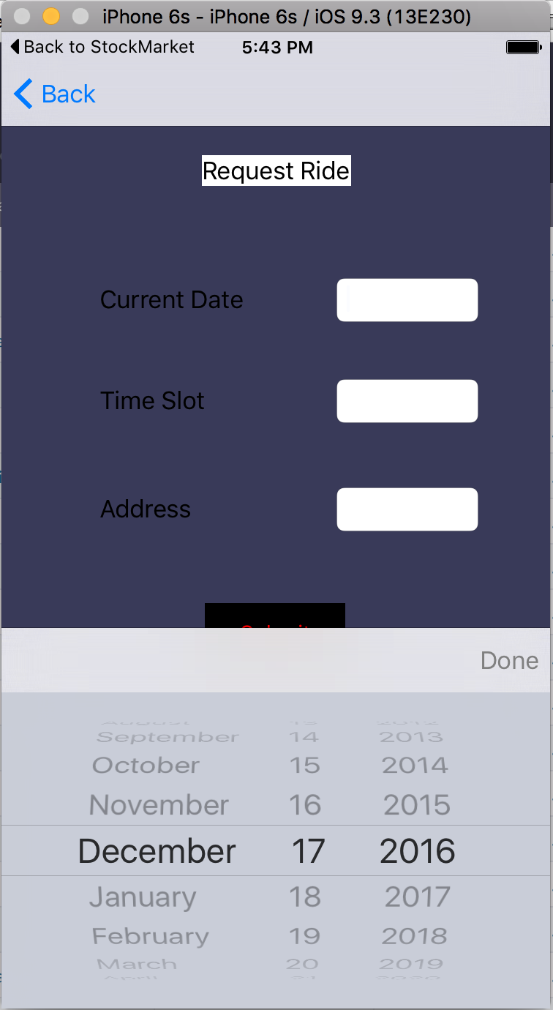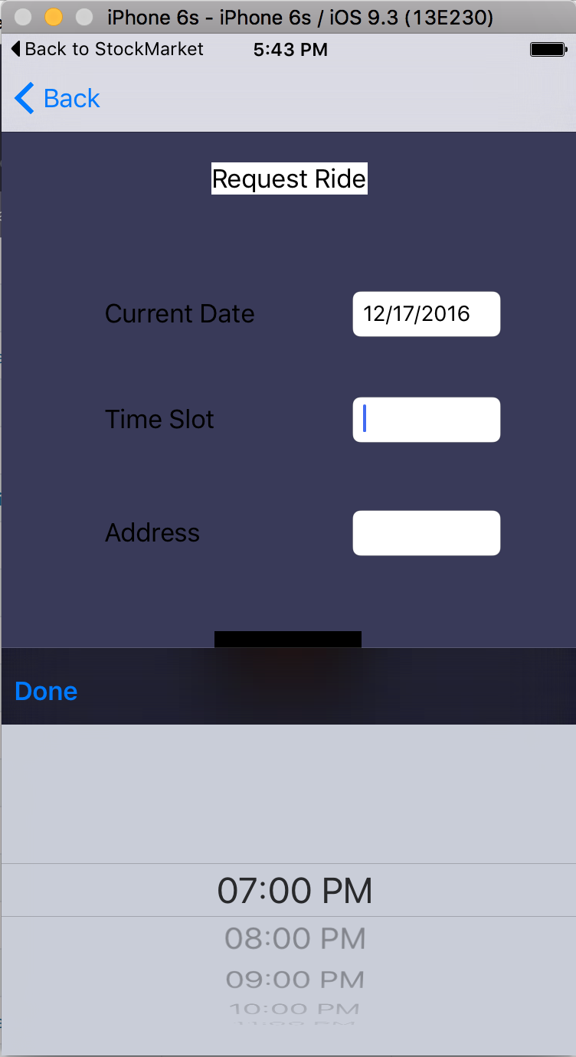

## Slots filled and NUPD help Screen:

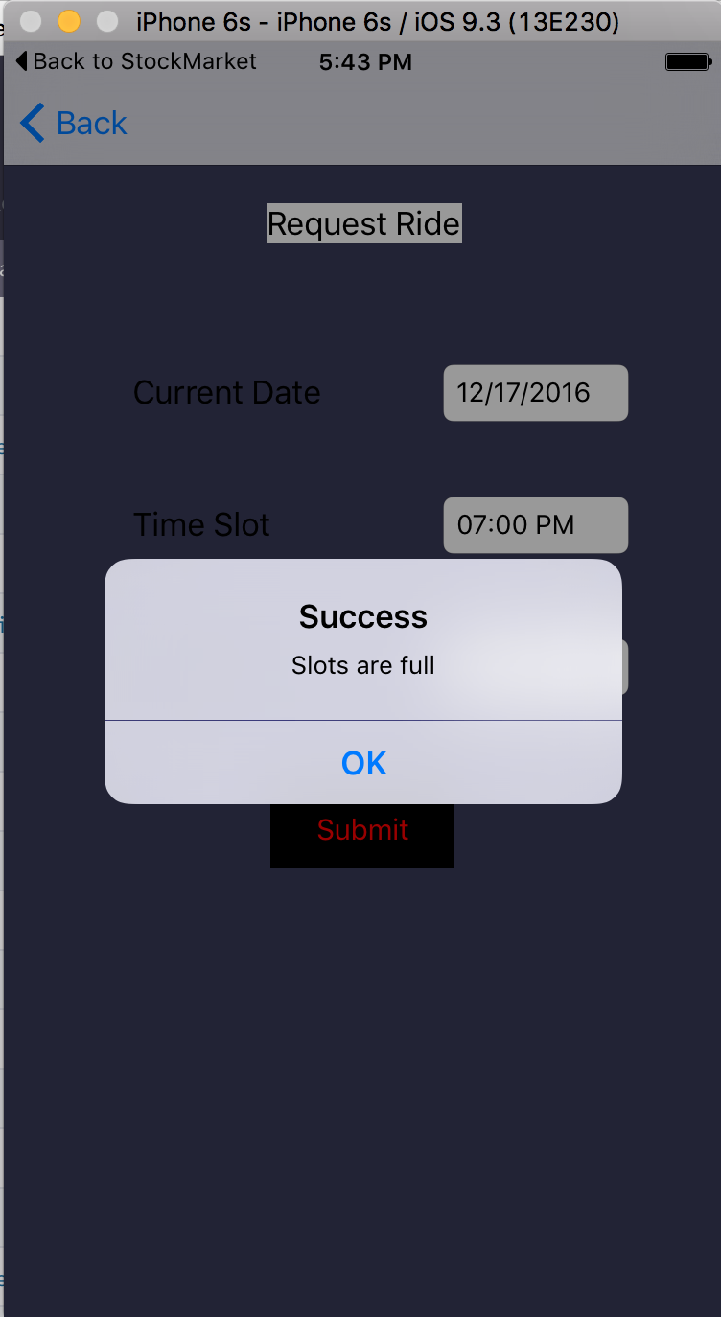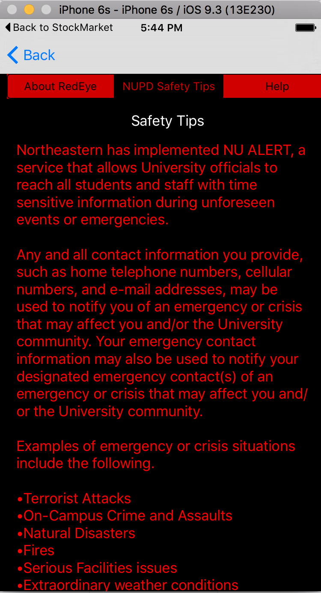

## Trend Analysis of rides for each hour in terms of counts as well as percentage:

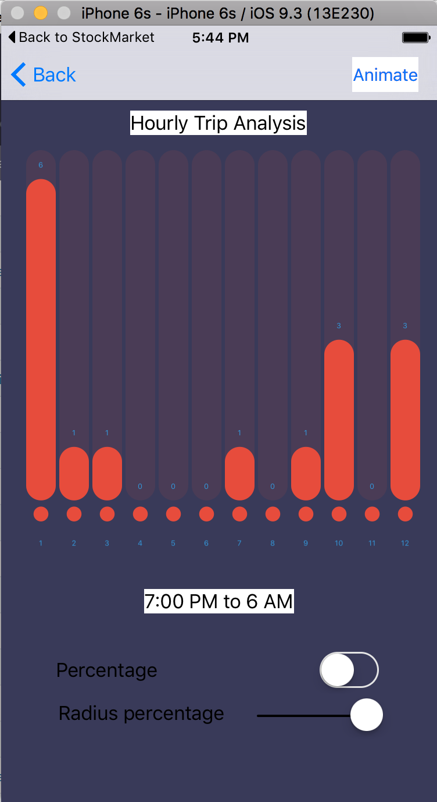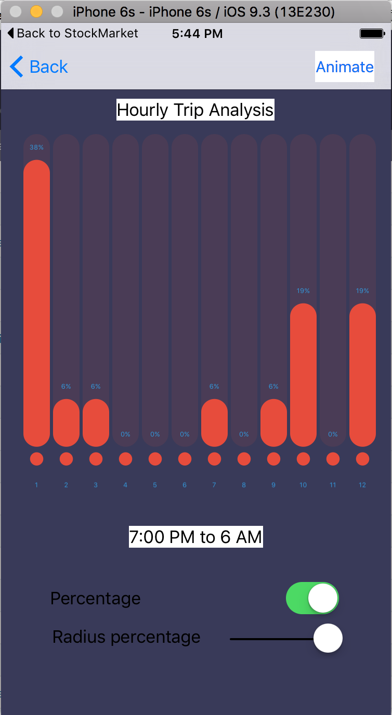

## Shuttle Locator and Student booking histories for Driver:

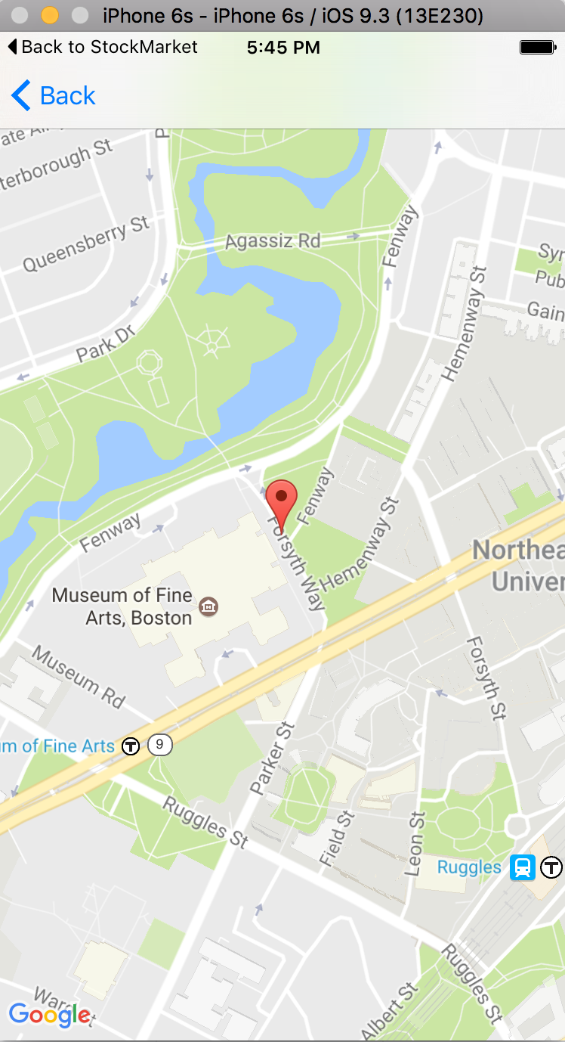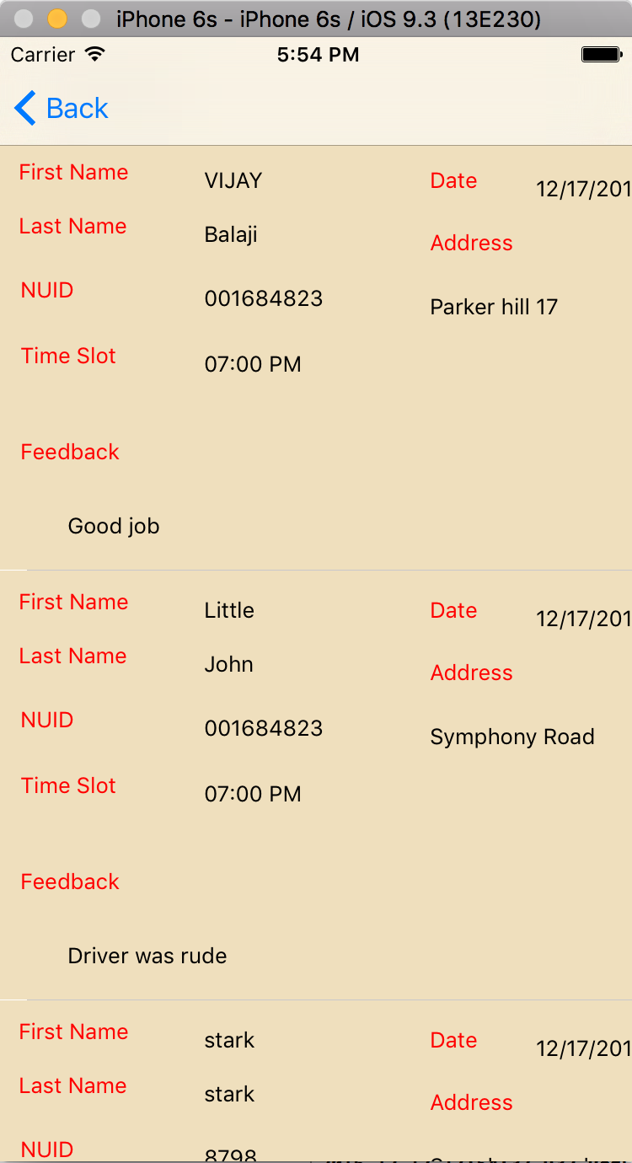

## Back4app Server integration:

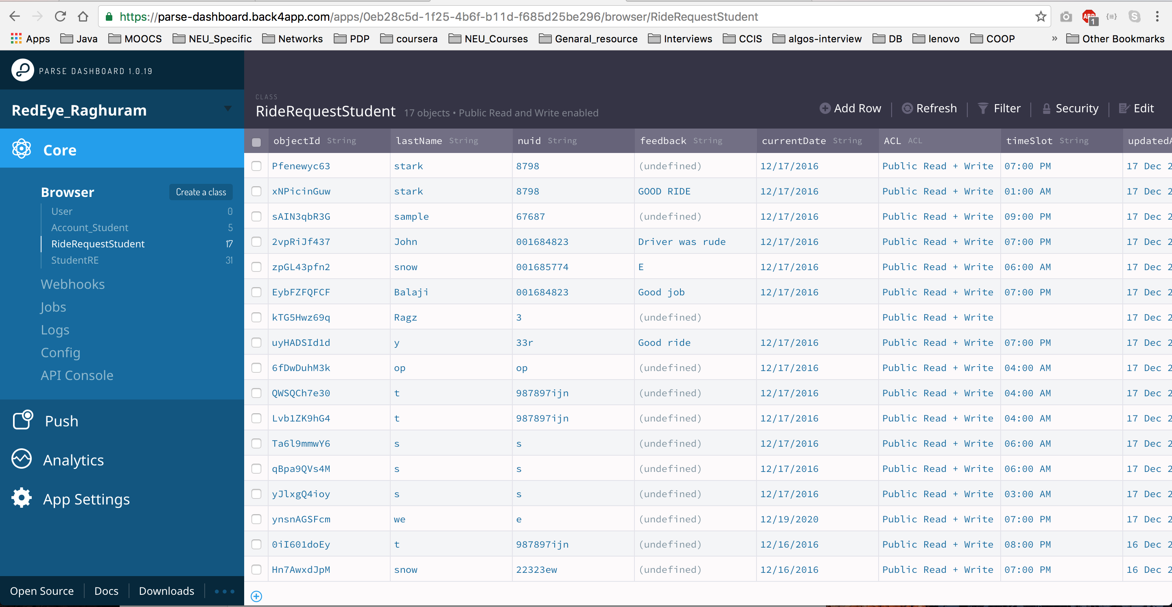

# Future Scope:

The shuttle driver will be able to view the GPS in his tablet based on the shortest optimized time or shortest optimized distance for the addresses registered for a particular time slot which can save the travel time as well as fuel.